# Lab Week 10: Sequential Data (and some Generative Models)

In this lab we will look at examples working with sequential data. You will apply various deep learning-based models.

Do not worry if you do not manage to finish *all* the tasks. Most of the steps in tasks 1-3 are very similar and the most important takeaway from this lab should be a general understanding of the basic procedures to prepare sequential data and the various ways that different models can be applied.

**Preparation:** You should ensure that you have set up your code editor connected to your Anaconda environment. Alternatively, you can also download and import the lab environment on GCU learn located in the Weeks/Units 🡪 Lab Setup Tutorial Section 🡪 *lab_environment_dl.yml*

# Task 1: Lecture Examples

The code for task 1 is similar to the one shown in last weeks lecture. It is located in “*Task 1 – lecture code time series.ipynb”*

It contains sample code of a fully connected, a convolutional and a recurrent neural network to predict a time series forecast on artificial data. Work through the code and then attempt the following exercises:

***Exercise 1:***

Make the time series, that is artificially generated, longer. (e.g. length > 10000). Rerun the experiments and check if the models still perform the same?

***Exercise 2:***

With the increasing length of the sequential data, can you come up with a larger architecture for each of the models? Simply add some layers or change the number of. You could also train for more epochs if your hardware allows this. Does the performance increase?

# Task 2: Time Series Forecasting with TensorFlow

In the next task, you will work through an example tutorial created by the authors of TensorFlow. This will again show various models and uses similar approaches to the previous task.

You can find the tutorial here: <https://www.tensorflow.org/tutorials/structured_data/time_series>

Either run this locally on your machine, or use Google Collab for this. The aim for this task is not to try each single line of code, rather than the concepts behind it. The shifting window approach is similar to what was performed in Task 1 but uses a different implementation.

If you have any questions about the code used there, please do not hesitate to ask your Lab Tutor.

# Task 3: Making Predictions with Sequences Using Recurrent Neural Networks

For task 3 you will use of the book: **Python Machine Learning by Example, Liu, Y., (2020),** by Packt Publishing.

You can access the digital version of this book by going to the module’s sidebar, clicking on Resource-Lists and then you should be able to see the E-Book version.

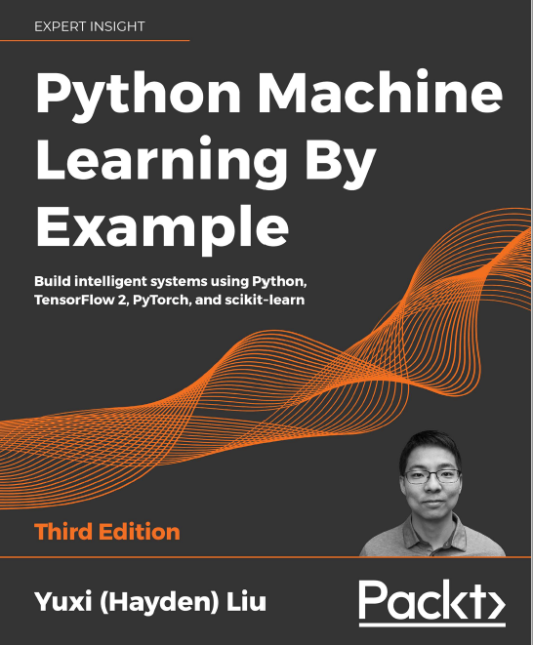

Figure 1 Python Machine Learning by Example: Book

You should then open the book in a new window or tab, as you will be referring back to this.

In this task, you should work through ***Chapter 13*: Making Predictions with Sequences Using Recurrent Neural Networks** of this book. To aid you in this, the code has been provided in the jupyter notebook: “*Task 3 – predictions with rnns.ipynb”.*

This task works with sequential data, but also ties back to last week’s content about NLP.

# Extra Task

In the previous tasks we have looked at sequential data, although the lecture also covered some generative models.

If you want to see how Generative Adversarial Networks are implement, I recommend looking through the TensorFlow Guides [here.](https://www.tensorflow.org/tutorials/generative/dcgan)

If you want to simply experiment with generative models and see what kind of data they produce I would recommend to look through the following web resources:

* <https://thisxdoesnotexist.com/> : Different examples of various classes that are generated using GANs
* <https://www.craiyon.com/> : Text to image generate using [DALL-E Mini](https://wandb.ai/dalle-mini/dalle-mini/reports/DALL-E-Mini-Explained-with-Demo--Vmlldzo4NjIxODA)